1 Introduction to Game Maker

What is Game Maker?
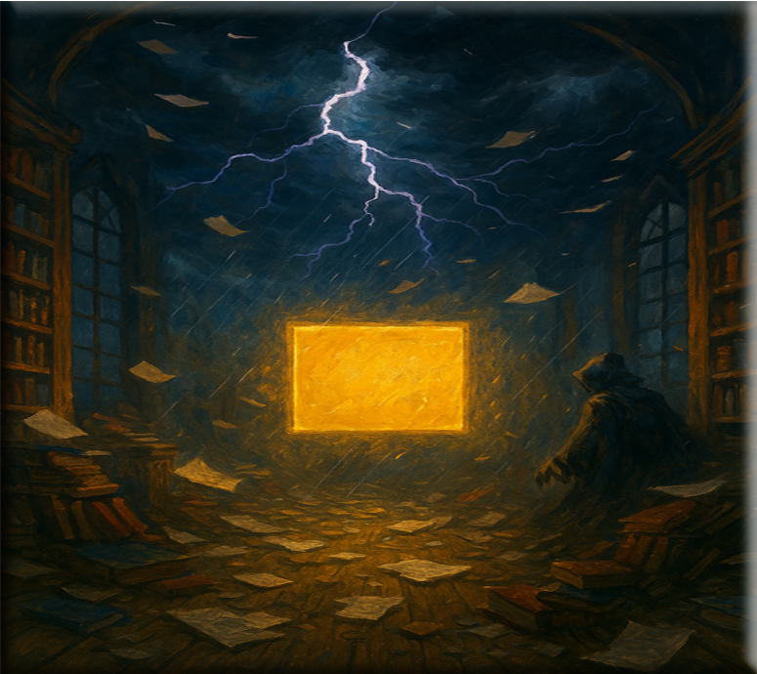
Game Maker is a free Game Making platform. You can download Game Maker here.
Game Maker Download Site
In Game Maker, you can use either a drag and drop visual programming for your game, or use the GML language, which is sort of like either JavaScript or C-like languages, but it is the language that was created for and used by the Game Maker app.

To Create Your First Game
Click on Game and Blank Game will show up below it. Then click on Blank game to start.
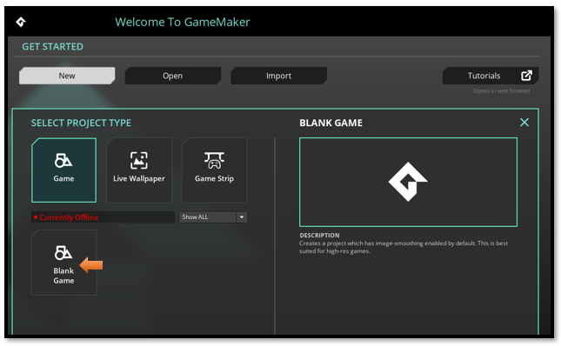
Give a name to the Project, and the hit the Let’s Go! button.
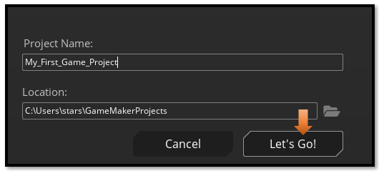
This is the Game Interface, when it first starts up.
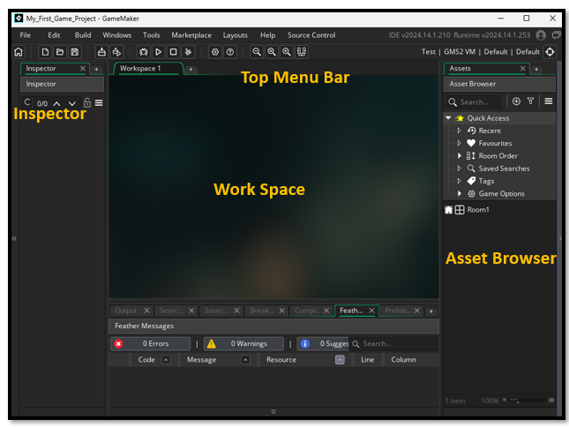
If you are used to earlier versions of Game Maker, you might be confused with the new look of your Asset Browser.

